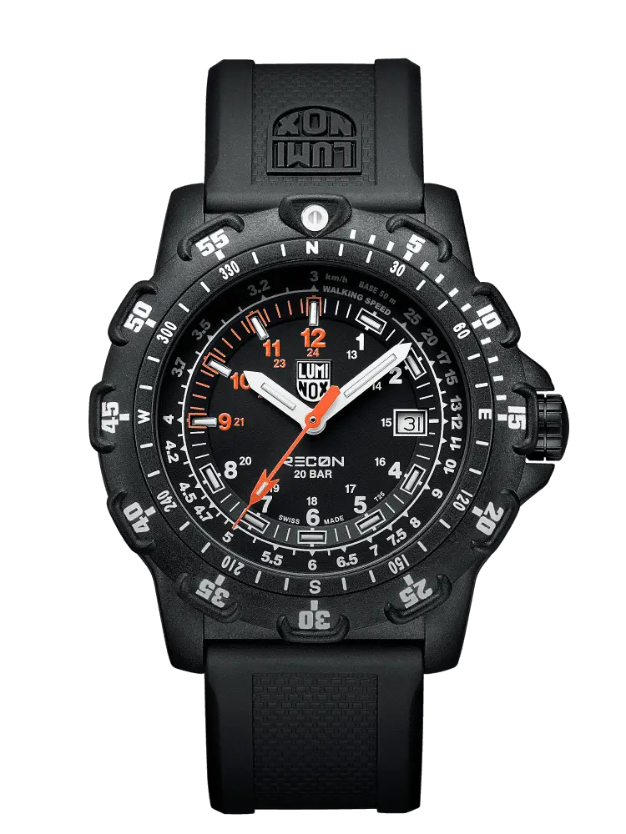Description: Luminox is a premium Swiss watch brand known for its durable and high-performance tactical watches. It is specially designed for military personnel, law enforcement, divers, and adventure enthusiasts. The most unique feature of Luminox watches is their **self-powered illumination system**, which allows them to glow in the dark without relying on external light sources. This technology lasts for up to 25 years, making them perfect for night missions and extreme conditions. Luminox watches have a rugged and water-resistant design, making them ideal for tough environments. Besides being highly functional, they also offer a stylish and powerful look, making them a popular choice among professionals and watch enthusiasts.